Assessment Task 2: Project Portfolio

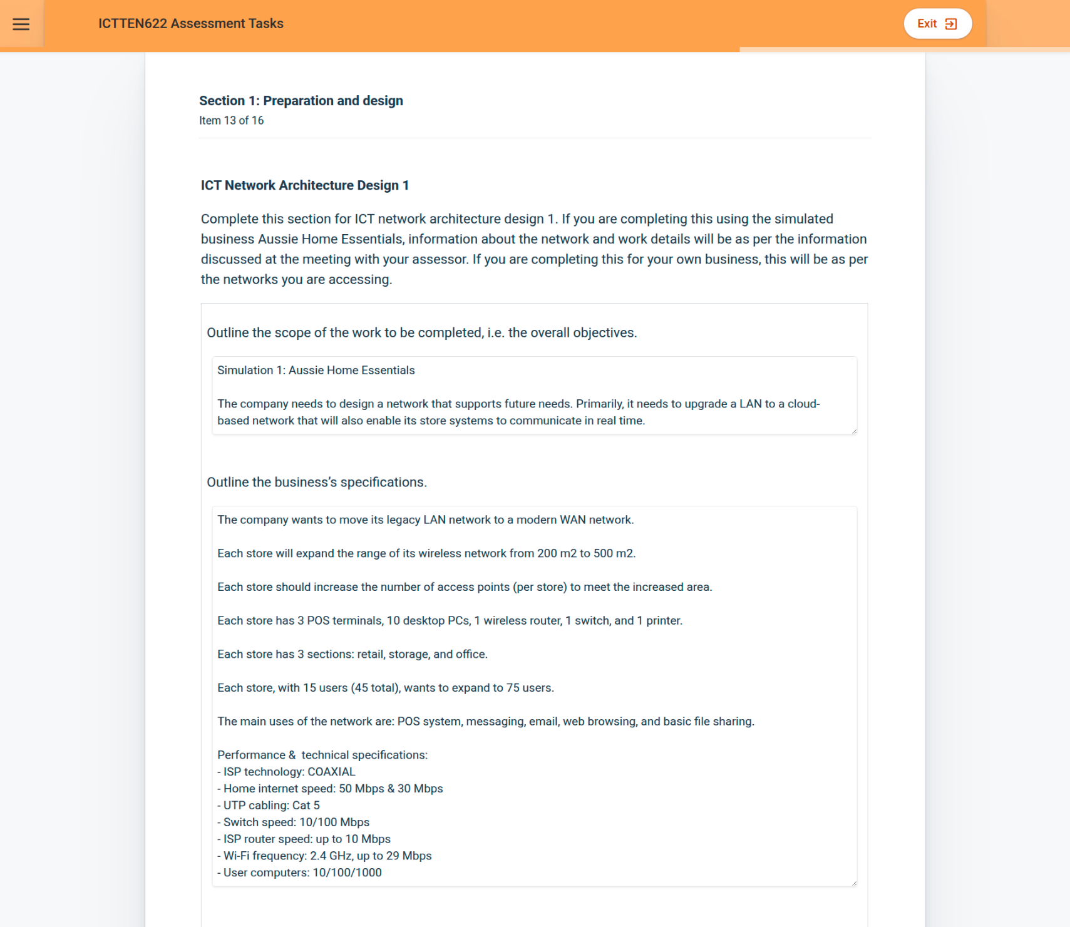

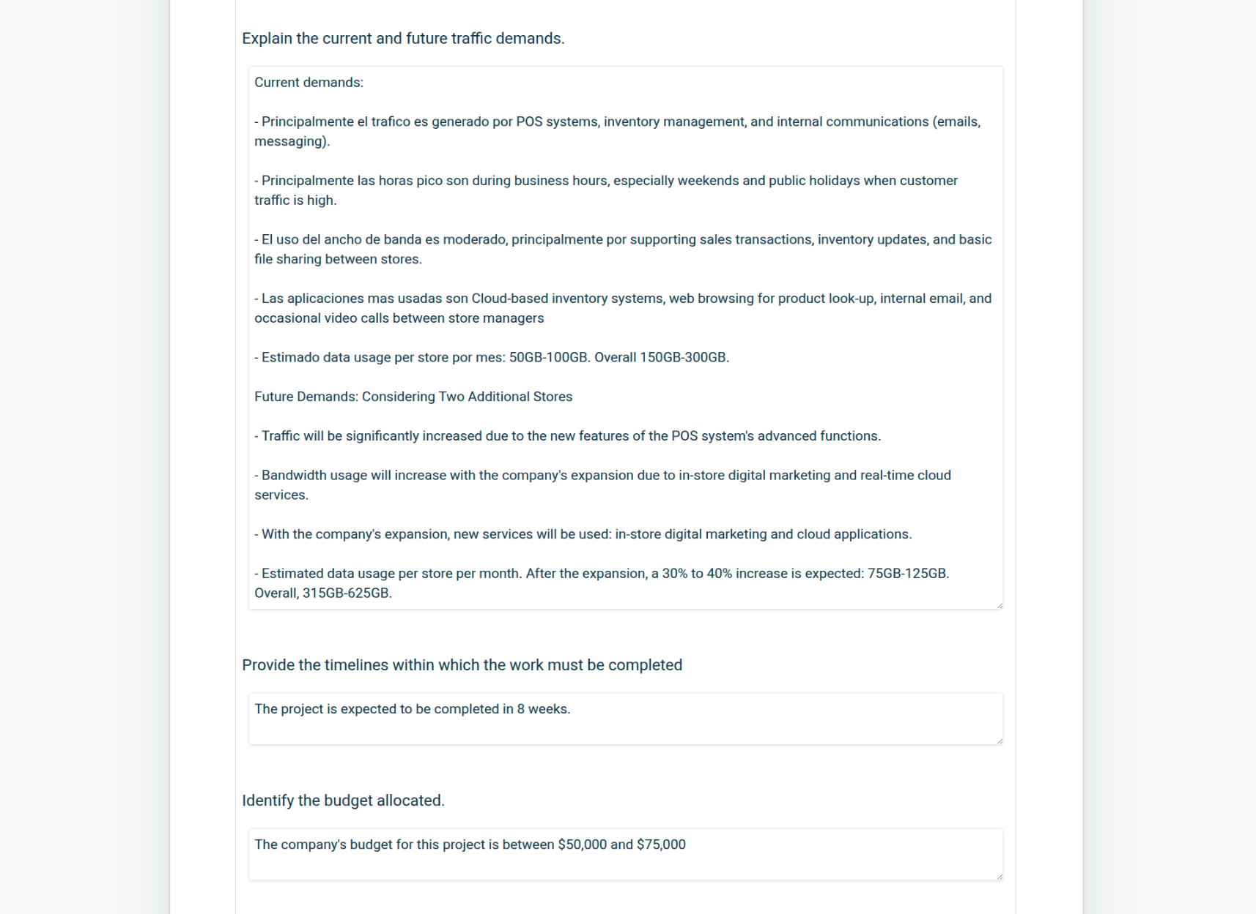

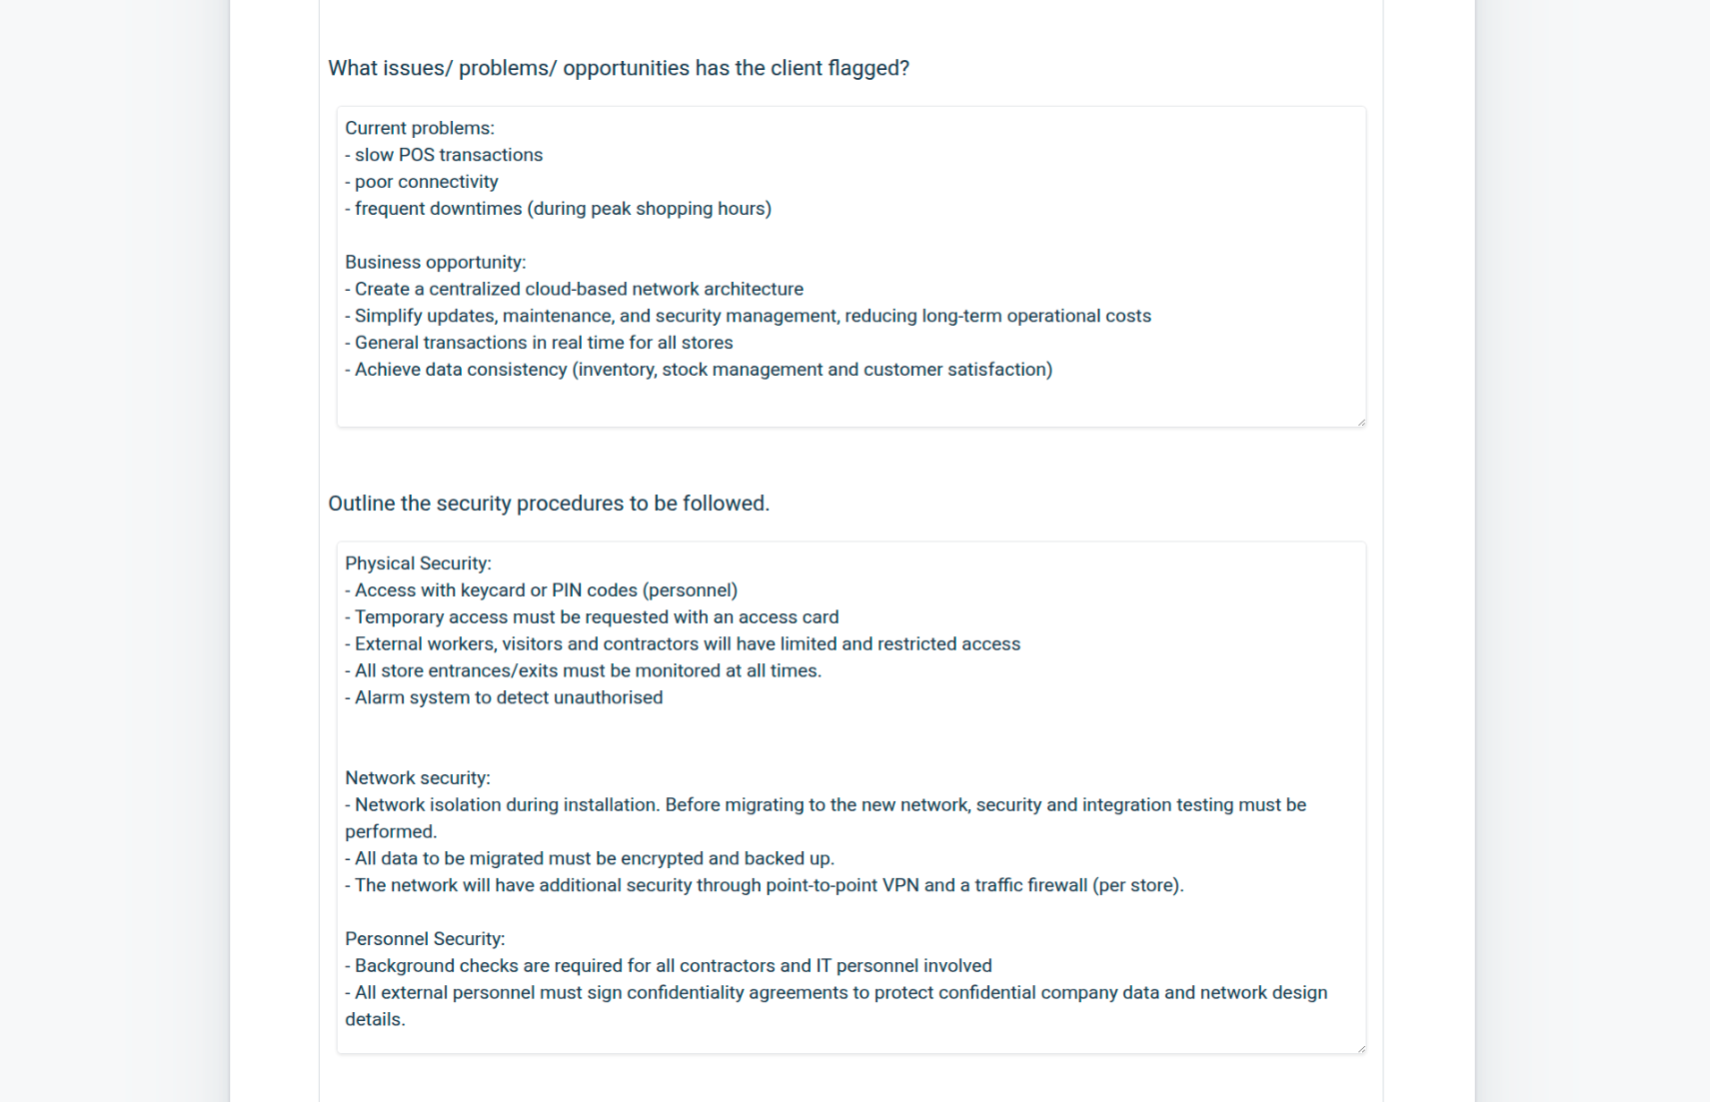



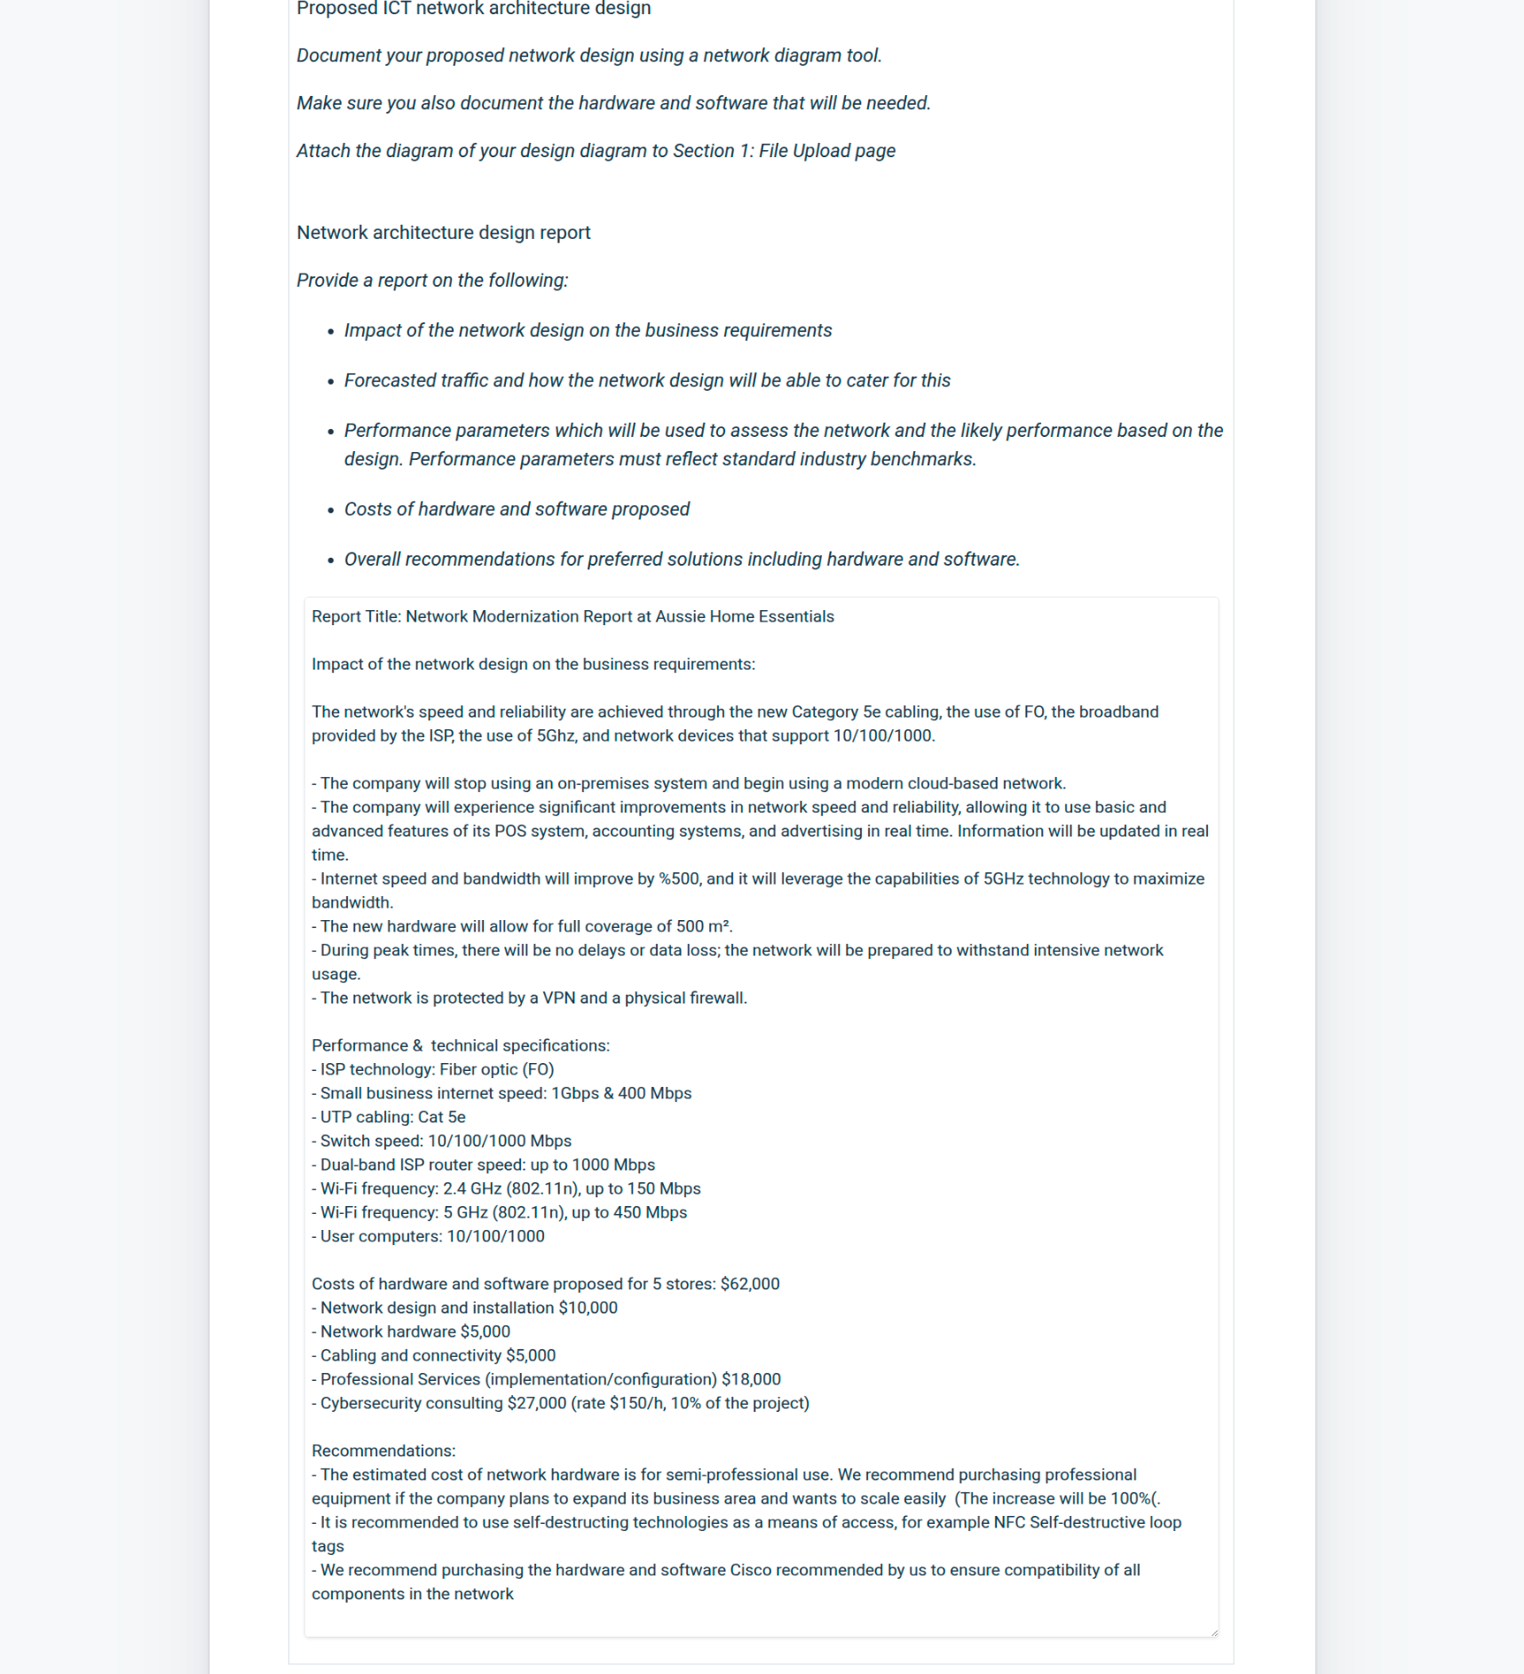

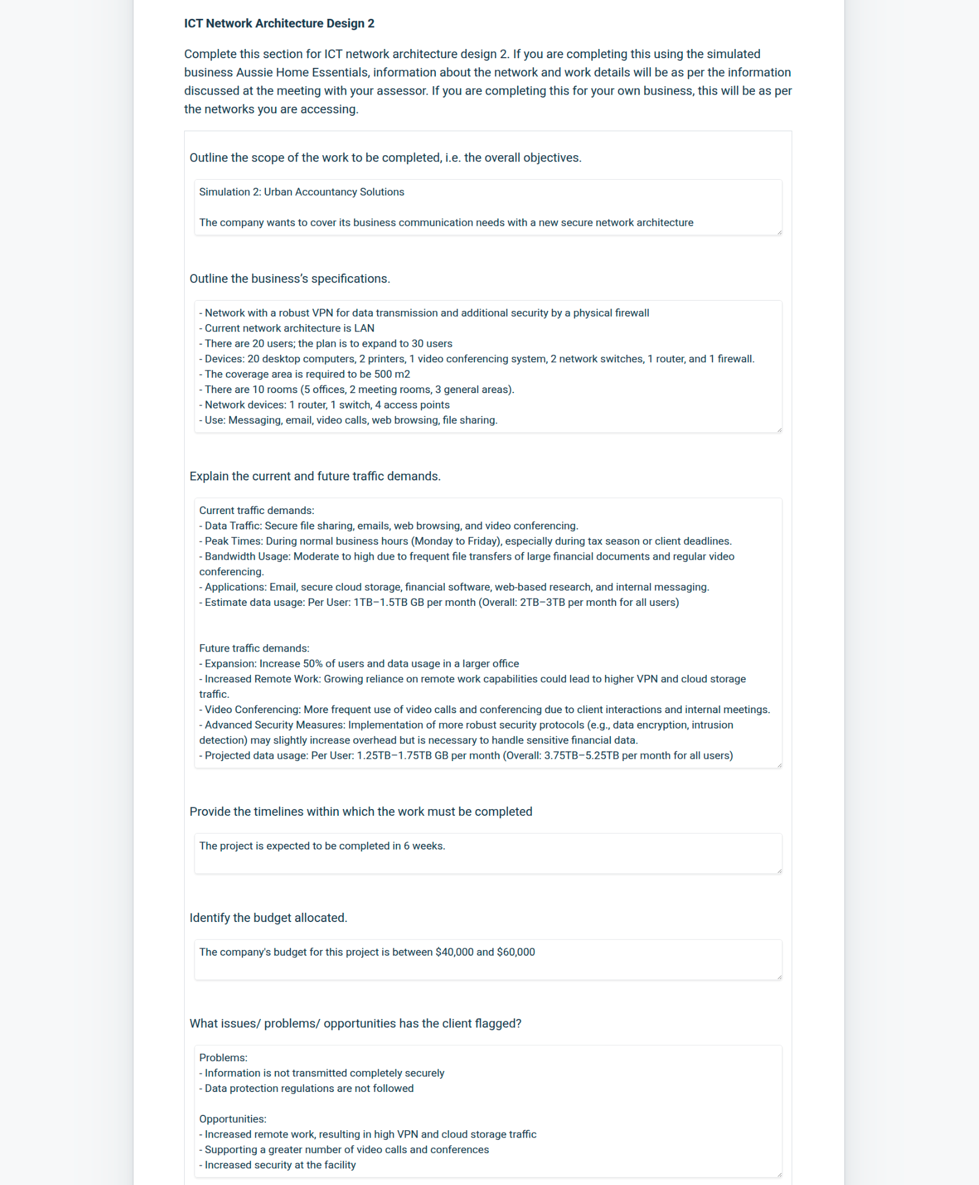



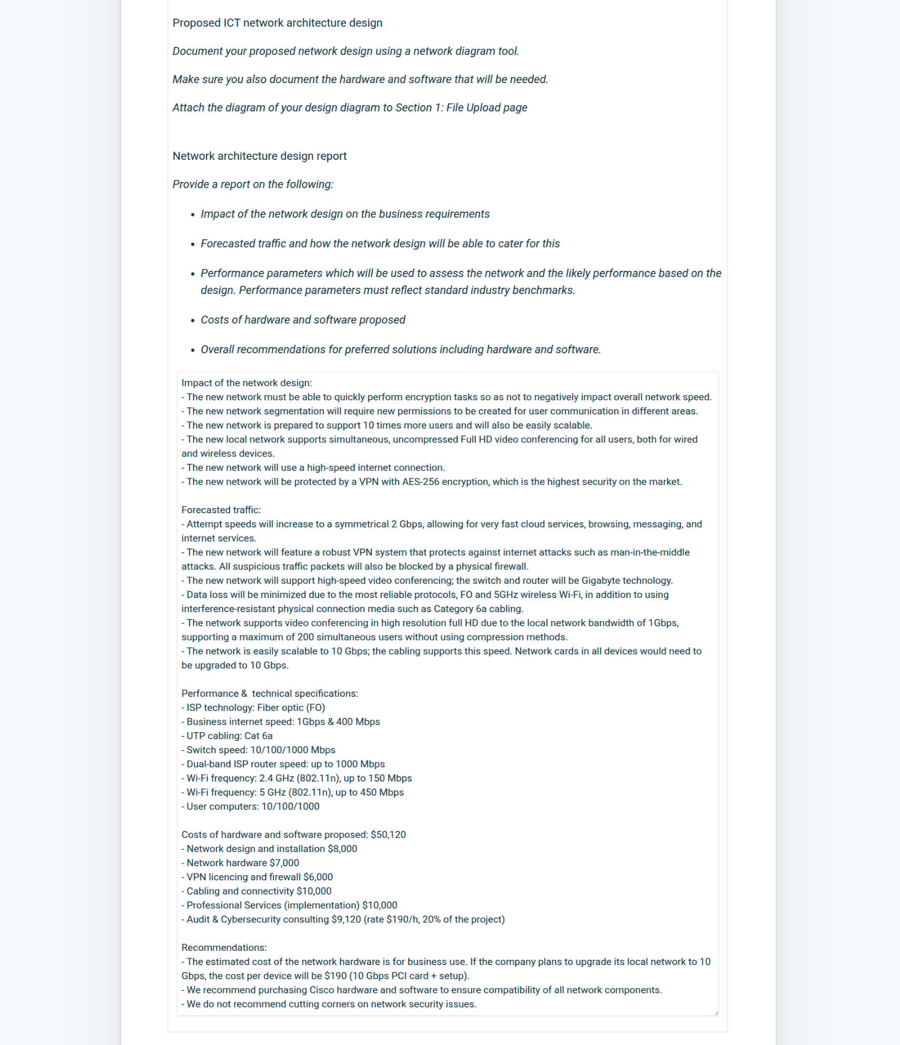

Training and support

Training on the new physical security system. To inform all employees about:

- new physical security regulations

- access to restricted areas

- reporting suspicious events

- reporting emergencies

- visitors

- use of the self-destructing TAG system.

CCTV system training. To introduce the cloud-based surveillance system

- information use consent

- new regulations.

Cybercrime training. To raise employee awareness of online risks.

- New regulations

- Phishing and cyberattacks

- Protection of corporate information

Workplace safety training

- health and safety regulations

- safety standards

- mandatory use of PPE in risk areas

Cloud-based POS system training

- POS system usage

- Issue reporting

New Technology Training

- How to use the 5GHz network, differences, and advantages

- Limitations and advantages of 2.5GHz/5GHz

- How to use new marketing real-time system

\*\*\*\*\*\*\*\*\*\*\*\*\*\*\*\*\*

Training and support

Training on the new physical security system with biometric readers. To inform all employees about:

- new physical security regulations

- access to restricted areas

- reporting suspicious events

- reporting emergencies

- visitors

- use of the self-destructing TAG system.

CCTV system training. To introduce the cloud-based surveillance system

- consent to the use of biometric information

- new regulations.

Cybercrime training. To raise employee awareness of online risks.

- New regulations

- Phishing and cyberattacks

- Protection of corporate information

Workplace safety training

- health and safety regulations

- safety standards

New Technology Training

- How to use the 5GHz network, differences, and advantages

- Limitations and advantages of 2.5GHz/5GHz

- FO and uses for multicast video-conferences in FullHD

Security training

- How to verify that you are connected to a VPN

- How to send encrypted information on the internet

- General information on data privacy